

Dynamic®:GATEWAY
Technology Guide
Dynamic®:GATEWAY
Technology Guide
Contents
Introduction 3
Design Goals 3
Platform Independence 3
Network Independence 3
Distributed Architecture 3
Reduced Vulnerability To System Failure 3
Fully Integrated Relational Database 3
Shared Memory 3
Reduced Implementation Time 3
Dynamic:GATEWAY Overview 4
Dynamic:GATEWAY Solution 5
Abstraction 5
Communication Layer 5
Platform Layer 5
Database Layer 5
Software Development Kit 5
Scripting Language 5
Interoperability 6
Dynamic Dashboard 6
Dynamic:GATEWAY Components 6
Dynamic:GATEWAY Services 6
Foundation Services 6
Cross Platform Processing/Continuous Availability 6
Distributed Processing and Scalability 6
Parallelism 7
Integrated GUI Interface 7
Communications Services 7
Protocol Independence 7
Ease of Configuration 7
Application Services 7
Message Management 7
System Diagnostics 7
Security Services 8
Access Security 8
Data Security 8
Database Design 8
PCI DSS Certification 8
Conclusion 8

Dynamic®:GATEWAY
Technology Guide
Introduction
Hi-Tech Solution for a Rapidly Changing Business Landscape
Organizations are faced with an ever changing and expanding data processing landscape where disparate systems are expected to work together to provide a seamlessly integrated solutions for content delivery. The challenge for organizations is to maintain a stable customer interface, while continually changing its IT infrastructure to incorporate new technologies for improved performance, while reducing overall operating costs. The Dynamic®:GATEWAY provides a modern, scalable, and portable framework for building the applications that enable them to meet these vastly diverse requirements.
Paxus’ goal is to provide clients with messaging middleware that is able to transcend the traditional platform and operating system boundaries. The Dynamic:GATEWAY ability to execute as one system across platforms and operating systems provides customers with a highly flexible and powerful development framework.
Dynamic:GATEWAY is a cutting-edge messaging middleware solution that enables customers to seamlessly integrate legacy applications and modern content delivery solutions. The gateway is the foundation on which the Dynamic suite of payment products is built. Paxus is a privately held organization based in Omaha, Nebraska. This independence allows Paxus to make strategic business decisions that are responsive to customer, market, and technology needs. Paxus has gathered a team of professionals with vastly different areas of expertise and backgrounds spanning many industries that require modern, high-availability solutions. We have combined this wealth of knowledge and experience to build a modern messaging middleware solution that will be the benchmark in many industries.
Design Goals
Paxus LLC has been involved with developing and implementing Online Transaction Processing (OLTP) and payment applications for many years and understands the problems associated with these systems. In 2003, we set a goal to develop a new application that would provide all of the features that we have found to be necessary and add features that set us apart from everyone else in the market. Below are the specific design goals used in developing the Dynamic:GATEWAY:
- Distributed
- Scalable
- Easily customized
- Portable
- Available
- Flexible
- Extendible
Platform Independence
The application must be able to run on any desired operating system, making platform support decisions easier for the customer.
Network Independence
Communication protocol requirements change from industry to industry and customer to customer. By designing an application that doesn’t rely on communication specifics, portability is more easily obtained.
Distributed Architecture
The system must be designed to run on single or multiple machines without special programming. This allows for the integration of additional hardware as transaction volumes increase.
Reduced Vulnerability To System Failure
By eliminating any single point of failure in the software, availability of the system is increased, reducing potential losses associated with downtime.
Fully Integrated Relational Database
Using a relational database to store all of the data within a system makes that information available to the entire enterprise. The RDBMS vendor also provides functionality, such as transaction management, that adds to the integrity of the system.
Shared Memory
By using shared memory, the speed of processing is dramatically improved and the possibility of data truncation is reduced.
Reduced Implementation Time
Traditionally, installation and initial configuration of OLTP systems have been complex and time consuming. The goal was to make an application that was simple and quick to install and configure.

Dynamic:GATEWAY Overview
Dynamic:GATEWAY is a high-performance, high-availability messaging middleware used as a foundation for application development. It is used as the messaging middleware for the Paxus Dynamicsuite of products. Its scalability and reliability is achieved by its ability to execute across multiple processors and systems. Therefore, a single processor or component failure will not affect the overall operation of the Dynamic:GATEWAY or the application running within it. Its component failure recovery function will re-establish communications or IO paths with entities that were lost as a result of the component failure. The limit to the component failure recovery will be the level of redundancy built into the network. The Dynamic:GATEWAY handles all the communications, thread management, queue management, message prioritization, and system related functions.
Dynamic:GATEWAY is an object-oriented framework that implements many core patterns for concurrent communication. Dynamic:GATEWAY provides a rich set of reusable C++ wrapper facades and framework components that perform common communication software tasks across a range of OS platforms. The communication software tasks provided by Gateway include event de-multiplexing and event handler dispatching, signal handling, service initialization, inter-process communication, shared memory management, message routing, dynamic (re)configuration of distributed services, and concurrent execution and synchronization.
To reduce complexity, and permit functional sub-setting, Dynamic:GATEWAY is designed using a layered architecture. The capabilities provided by Dynamic:GATEWAY span the session, presentation, and application layers in the OSI reference model. The foundation of the Dynamic:GATEWAY is its combination of an OS adaptation layer and C++ wrapper facades that encapsulate core OS network programming mechanisms to run portably on all platforms.
Dynamic:GATEWAY is targeted for engineers of high-performance and real-time communication services and applications. It simplifies the development of network applications and services that utilize inter-process communication, event de-multiplexing, explicit dynamic linking, and concurrency. In addition, the Dynamic:GATEWAY automates system configuration and reconfiguration by dynamically linking services into applications at run-time and executing these services in one or more processes or threads.
Dynamic:GATEWAY Solution
Abstraction
Paxus’ Dynamic:GATEWAY provides an abstraction layer that isolates business objects on the application platform from the complexities of interfacing to multiple endpoints, thread management, queue management, database access, and system functions. Its use of the most modern fourth generation object-oriented methodologies allows developers to concentrate on developing and fine-tuning the required business functions instead of arcane development rules. The database, communications, and operating system are abstracted from the application to avoid added complexities for application developers.
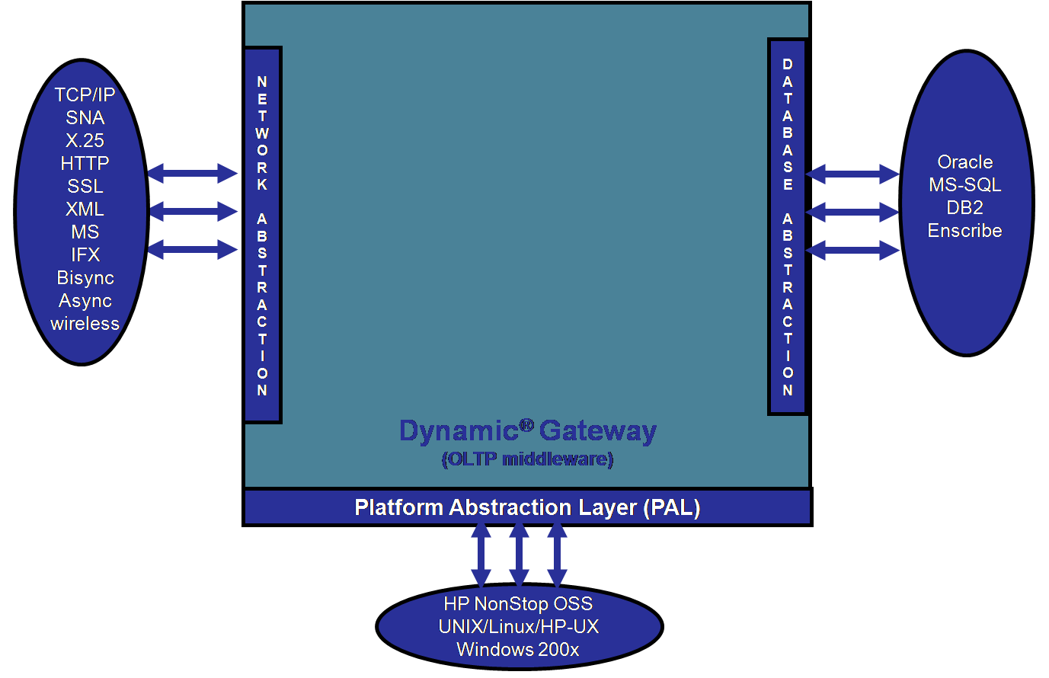
Figure 1 – Dynamic Abstraction Layers
Communication Layer
Communication protocol issues are handled by Dynamic ESB (Enterprise Service Bus). The ESB is the gateway to the network. ESB handles traffic from many disparate systems, technologies, and platforms, and converts the data and communications protocols into an enterprise standard that can be used to feed internal systems. Dynamic ESB provides customers with a single data backbone, with multiple entry and exit formats.
Platform Layer
The Dynamic:GATEWAY is also abstracted from the underlying operating system by a Platform Abstract Layer. All logic that is specific to a particular operating system is grouped together. This simplifies the process of porting to another operating system and improves the stability of the system. All platform specific logic resides in this layer and is made available to all Dynamic applications.
Database Layer
The other layer of abstraction is interacting with the database. The DBAPI (Database Application Programming Interface) contains the necessary functions to process the required business logic. This methodology allows the application to process transactions without knowing the underlying physical data model. The DBAPI uses embedded SQL to access the database server and allows the SQL to be tuned for each of the supported database vendors.
Software Development Kit
The powerful Software Development Kit (SDK) simplifies application development for engineers once business requirements have been defined. The Dynamic:GATEWAY runs on UNIX, Linux, HP NonStop OSS, or Windows platforms to allow superior scalability and flexibility. The SDK was developed with the vision that an experienced C++ developer can be productive within the environment with one week of training. Individual modules are developed by engineers and dynamically linked into the gateway. The SDK was designed to make it extremely easy for engineers with as little as one year of development experience to be productive. Modules are included in processing channels, as plug-ins and as command modules.
Scripting Language
The Dynamic:GATEWAY has a built-in flexible scripting language. This provides the developers with the ability to prototype products and services and enables organizations to quickly move ideas from a business concept to an operating proof of concept model, prior to incurring the cost of development for new products and features.

Interoperability
Each logical system within a customer’s installation can include as many Dynamic:GATEWAY nodes as required. A node is an executing copy of the Dynamic:GATEWAY. The nodes operate within the same environment to form a logical system. A logical system can operate on a single system or across multiple systems, with no restrictions on platform or operating system. The application software that handles the business functions can be simultaneously compiled for Windows, Linux, or UNIX. This provides customers with the ability to leverage existing hardware platforms with spare capacity to improve performance, while reducing overall hardware purchase costs. Multiple logical systems can share the same platforms, if required by business functions.
The Dynamic:GATEWAY’s ability to operate on various hardware platforms and operating systems makes it an ideal key component of the corporate information technology strategy. Customers can reduce the overall operating cost, including the cost of labor and training, by using the Dynamic:GATEWAY as the foundation for building the multitude of applications required to operate a viable business in today’s competitive market.
Dynamic Dashboard
The Dynamic:GATEWAY provides customers with the tools to monitor, control, and operate applications on all platforms with a common interface from a common operator console called the Dynamic Dashboard. The dashboard will improve productivity and reduce downtime and omissions by operators.
Dynamic:GATEWAY Components
Dynamic:GATEWAY nodes are the executing copies of the Dynamic:GATEWAY in a logical system. The business function application is built on this framework.
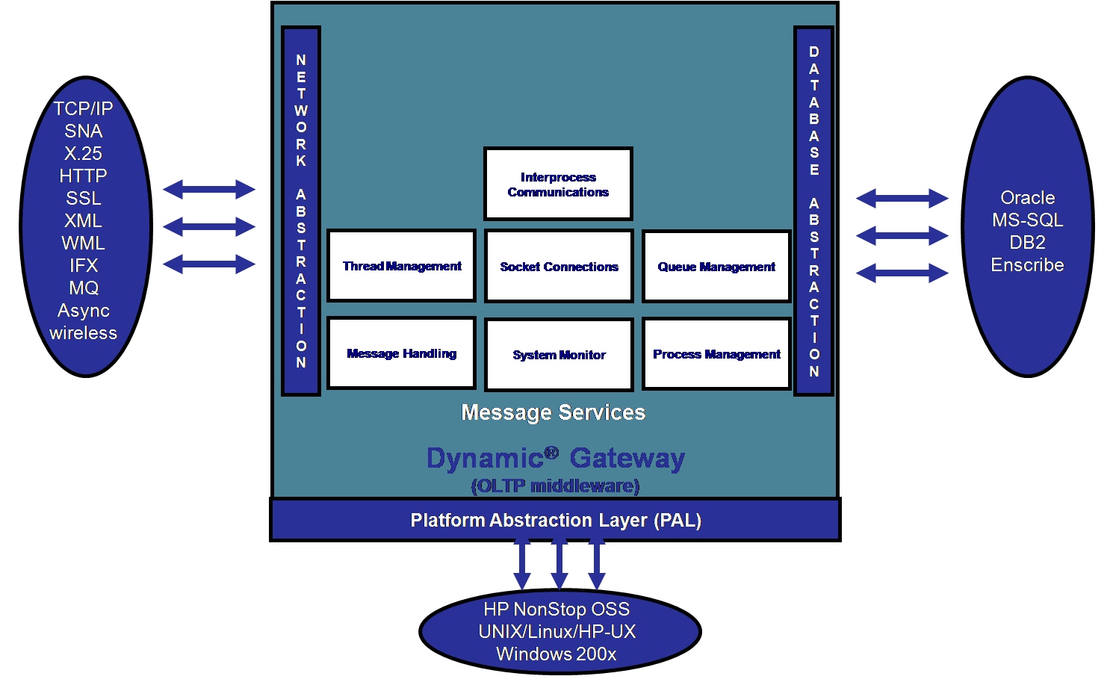
Figure 2 - Dynamic:GATEWAY Component Overview
The Dynamic:GATEWAY is a single executable object containing the base logic to manage the configuration, thread-management, queue management, database access, security, and system functions. Dynamic link libraries (DLLs) extend the core Dynamic:GATEWAY to reform it into an application for a specific task.
Dynamic:GATEWAY Services
Foundation Services
Cross Platform Processing/Continuous Availability
Paxus' approach to high availability is to encapsulate the functional complexity of operating in a multiple system environment into the Dynamic:GATEWAY. The ability to run a single Dynamic:GATEWAY node across multiple systems enables the system to continue processing through a loss of any one component within the system. This eliminates the requirement for fail-over processing at the Dynamic:GATEWAY and application software level, in the case of component failure. Its continuous availability is achieved by ensuring key component redundancy throughout the network.
Distributed Processing and Scalability
Paxus’ approach to distributed processing is designed based on a grid computing model. While its core functions of communication management, message queuing and thread management are handled by the primary Dynamic:GATEWAY nodes, the non-critical functions are outsourced to nodes running at a lesser priorities on remote systems. This ensures the high performance of the critical functions while leveraging unused capacity on other systems for non-critical functions.
The Dynamic:GATEWAY will expand and run on all available resources (clustered hardware platforms) with a simple change to the configuration. This will ensure that customers can increase processing capacity without having the penalty of an outage. This same function can be used to remove resources from the system for maintenance. This ensures continuous availability through hardware maintenance periods as well as application upgrades. Scalability is handled by increasing hardware within the system.
Parallelism
The Dynamic:GATEWAY’s ability to allow customers to tune the number of threads used for processing enables customers to better leverage their hardware investments. Each communication end point is handled as an independent thread. Once the data is received from an endpoint, the data is placed in the Gateway’s message queue for processing. The data is then retrieved and handed over to the application thread for processing.
Integrated GUI Interface
The Dynamic:GATEWAY’s user-friendly GUI application was designed based on standard Windows development methodologies. The GUI provides a command and control facility as well as a database interface. Its modular design ensures that customers have an integrated interface for access to all logical systems on the network. The Dynamic:GATEWAY’s XML-based command structure ensures that the operational functions of the network can be easily integrated into any automated command and control application.
Communications Services
Dynamic:GATEWAY communications services provide the following features:
Protocol Independence
Since TCP/IP is the standard communications protocol used by modern hardware and Operating Systems, the Dynamic:GATEWAY communicates using this native format. To support legacy protocols the Dynamic:GATEWAY integrates with an external protocol converter from one of Paxus’ business partners, Inetco. Inetco is a leading developer of high performance protocol converters for the payment industry.
Ease of Configuration
The Dynamic:GATEWAY utilizes a symbolic naming convention which allows users to reference logical system components. Its dynamic configuration function provides users with a simple interface to configure and maintain the logical system.
Application Services
The Dynamic:GATEWAY is architected around the concepts of modern fourth generation object-oriented programming. This ensures that applications have the benefit of the most modern technologies, while still being shielded from complicated database management, communications, thread-management, and system functions.
Message Management
The Dynamic:GATEWAY’s internal message queue is a solid data repository for handling all in-flight messages. All inbound data from external end-points are placed in the queue prior to being processed by the application layer. The resultant outbound data is then placed in the queue for delivery to the external endpoint. The protocol used to add and delete messages from the queue ensures the integrity and reliability of the queuing process.
The message data is passed to the application layer by the use of a message pointer in memory. This eliminates the latency caused by inter-process messaging. This results in a reduced use of system cycles and improves performance and reliability.
This message queue is shared among all nodes within a logical system across processors. This ensures that the messages in the queue have a redundant processing path at all times. Additionally, the outage of a single processor or system component will not impact in-flight messages. The queue will be written to disk during an orderly shutdown of the system. The queues are reinstated and processed during system startup.
The queue management process is handled by a message prioritization based on two distinct methodologies. The first is message prioritization. This ensures that messages are delivered and processed in the order selected by the configuration of the application software. The second method is based on a costing model. The costing model allows messages to be communicated over the most cost-effective path.
The Dynamic:GATEWAY includes a GUI dashboard for monitoring the gateway and the application. One of its key functions is to monitor the message queue, its depth, and status.
System Diagnostics
The Dynamic:GATEWAY contains all the tools necessary to trace and debug the application software. It contains a message-tracing facility that enables a user to trace a message through all its stages of processing. The trace data is logged to a trace file.
The Dynamic:GATEWAY includes the ability for messages and errors to be logged to a customer specified logging solution. The Gateway includes several standard logs and developers are allowed to define application-specific logs. The configuration system allows total control over which logs are used and the data that is included.
Security Services
Access Security
The Dynamic:GATEWAY’s advanced access control security provides a solid layer of protection for all database information. It also ensures that the command and control functions are secured. It enforces the highest standard for password creation and validation. Its access control security module was developed to meet and exceed the PCI DSS certification standards.
Data Security
The Dynamic:GATEWAY’s database functions include a feature for a fully encrypted database. All data elements within the database are encrypted. Additionally, all communication between nodes is also encrypted to ensure superior security. Dynamic:GATEWAY’s database and inter-nodal communication encryption methodology is designed to meet and exceed the PCI DSS certification standards.
Database Design
Paxus Dynamic:GATEWAY includes a sophisticated data management subsystem designed to be used in a variety of operating system environments. At the core of this database manager is Oracle’s embedded database manager. As an embedded database, Oracle’s database improves security (since messages to an embedded database cannot be intercepted), improves performance (since the low level interface eliminates the need to interpret SQL commands), and lowers cost (since the customer does not need to hire a DBA to support an external database, and there is no additional license for an external DBMS). Written in C++, the database integration is available for Dynamic:GATEWAY application developers to provide easy to use, yet flexible data file manipulation and indexing. Significant features include:
- advanced security
- database, table, and field-level access security by group
- all data and indexes stored in encrypted format
- superior replication capabilities that support hot, warm, and cold site implementations
- database transaction logging where logs are always encrypted
- fast table access via indices using various advanced techniques
- programs are portable over a wide variety of operating systems
- full file and record locking control that often exceeds the capabilities provided by the operating environment
- superior performance on network and multi-user systems using its multi-threaded capabilities
Paxus Dynamic:GATEWAY gives application developers simple yet sophisticated functionality that distinguishes the database from other solutions. Dynamic:GATEWAY’s database offers an easy to use XML method of database creation and maintenance. The database uses the simplified concepts of databases and tables, in addition to the standard concepts of records, fields, indices, and segments.
Paxus Dynamic:GATEWAY has the ability to generate tables based on definitions in an XML file. Additionally, the gateway has the ability to generate XML files that contain the database schema.
PCI DSS Certification
Data security is an important requirement for any solution deployed in the financial services industry. The Paxus Dynamic family of products has been audited for compliance with Visa’s Payment Authorization Best Practices (PABP) certification, now referred to as the Payment Card Industry Data Security Standard, (PCI DSS), under Visa’s Cardholder Information Security Program (CISP). The purpose of this certification is to ensure that all the components of the Paxus Dynamic family of products, Paxus’ software development methodology, and its quality control procedures are compliant with industry best practices for data security, as defined by Visa and the PCI Security Standards Council.
Conclusion
The Dynamic:GATEWAY represents the culmination of many years of experience and understanding of what it takes to run online payment systems. The result is an application development platform that is a step above anything available on the market, both in customer flexibility and scalability for the future.
If you wish to learn more about the Dynamic:GATEWAY and Dynamic Suite of Products for Payment Processing, please contact us at:
sales@paxus.com
402.218.1570

